

Candidate Guide to the Cambridge English Placement Test

Contents

1. What is the Cambridge English Placement Test? 4

2. Accessing the Placement Test 5

3. Taking the test 6

4. Results 9

# 1. What is the Cambridge English Placement Test?

The Cambridge English Placement Test is a quick and reliable online test for check your level of English, so that your school or college can place you in the right course for your level. This will help you learn more successfully.

It has been produced by Cambridge English Language Assessment, the world leader for assessing English language skills. Over 4 million people take Cambridge English exams every year.

More than 15,000 organisations, including universities, employers and government ministries worldwide, trust Cambridge English exams.

# 2. Accessing the Placement Test

When you sit at the PC to take the test, your test centre may have already logged you into the test system.

If not, you need to go to [www.metritests.com/metrica](http://www.metritests.com/metrica) and enter in your login details: your User ID, your Password and the Institution ID. And click on ‘Login’.

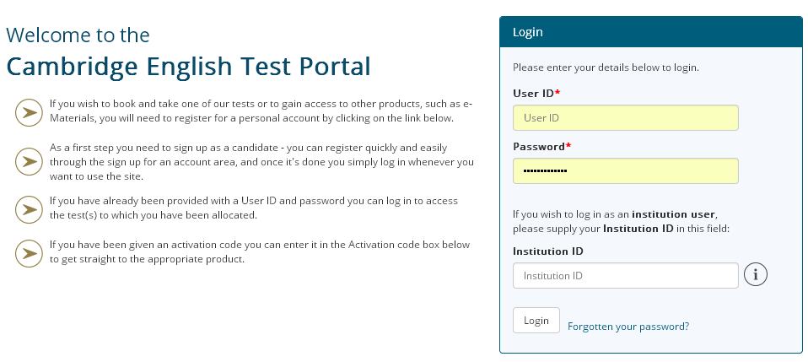

Then you will come to this screen which tells you which tests you can take. Click on the link in the first column:

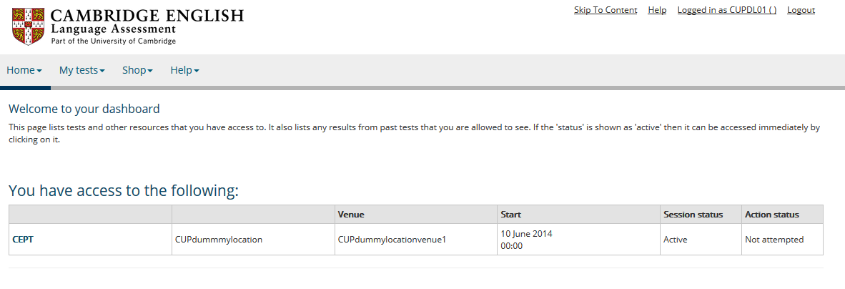

# 3. Taking the test

You will then enter the test system. The first screen is to help you check the sound on your PC. Tell the supervisor if you have any problems with the sound.

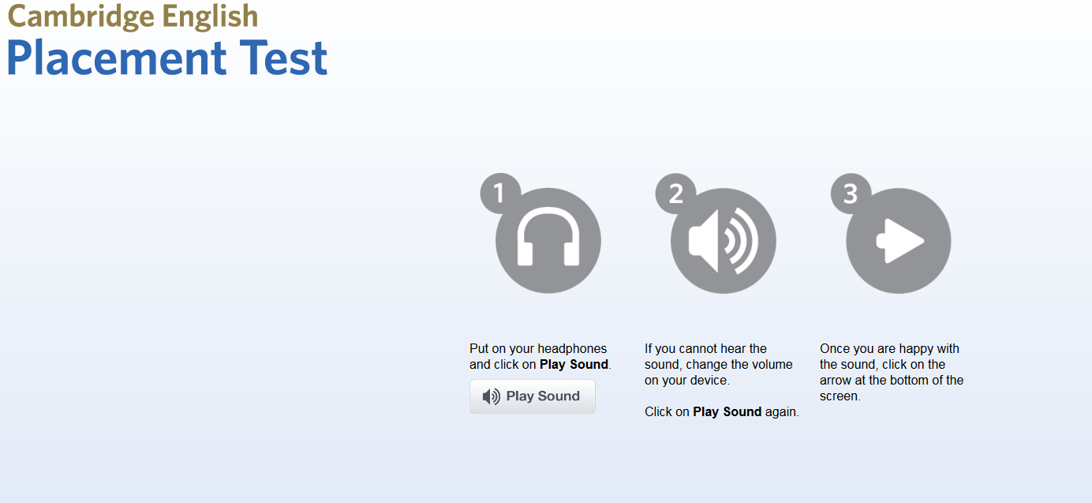

The next screen gives you some instructions on completing the test:

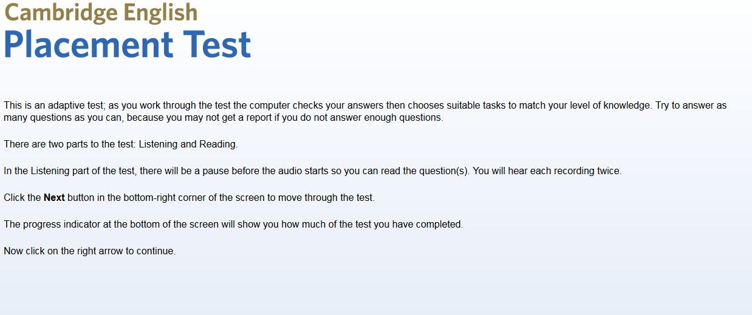

Note that the button to click to move on is in the bottom right corner of the screen.

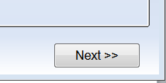

Then you will see a screen with a form to complete. Add your own information for each box.

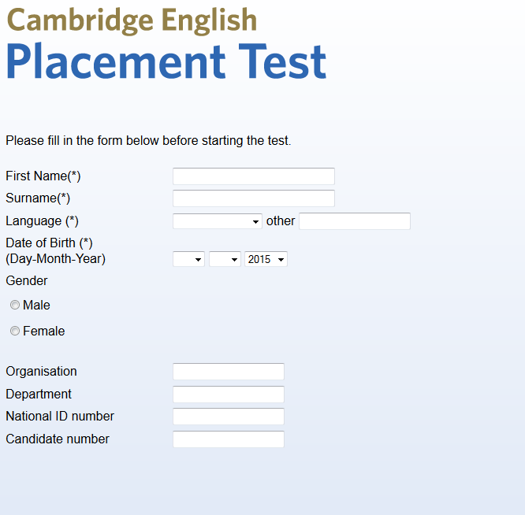

When you complete this form, you will go to the following screen. Click ‘Start’ when you are ready.

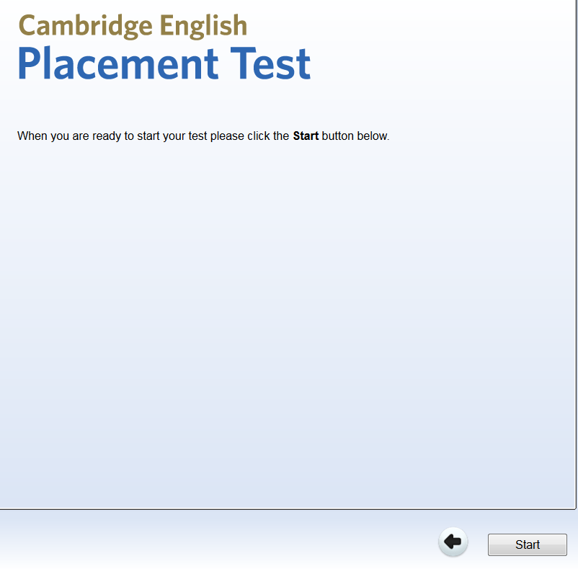

The first part of the test is the Listening part of the test. Click on ‘Next’ when you are ready.

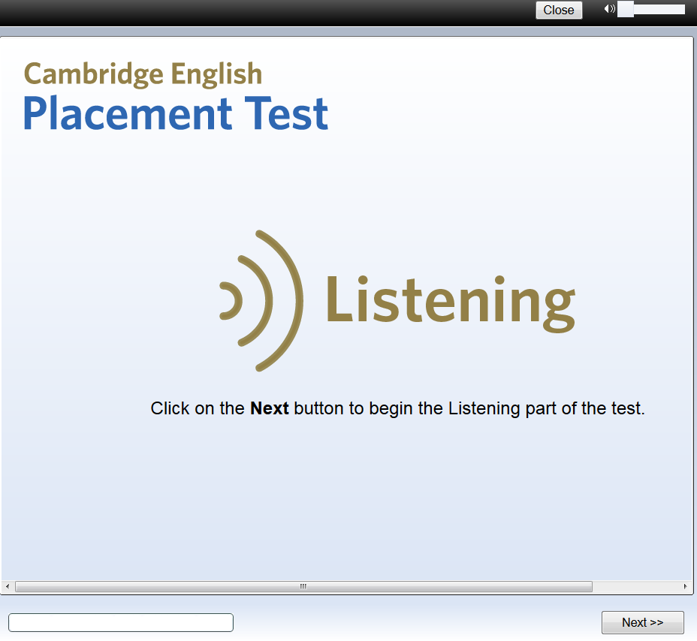

# 4. Results

When you complete the test, you will receive your test result. Below is an example:

